Test Case: tc001_SPX_Dev5_Crear_Nueva_Linea_Requisicion_Spot_Tipo_Cobro_CC
Step 1 - Enter username and password and click to button Enter : Credentials Entered
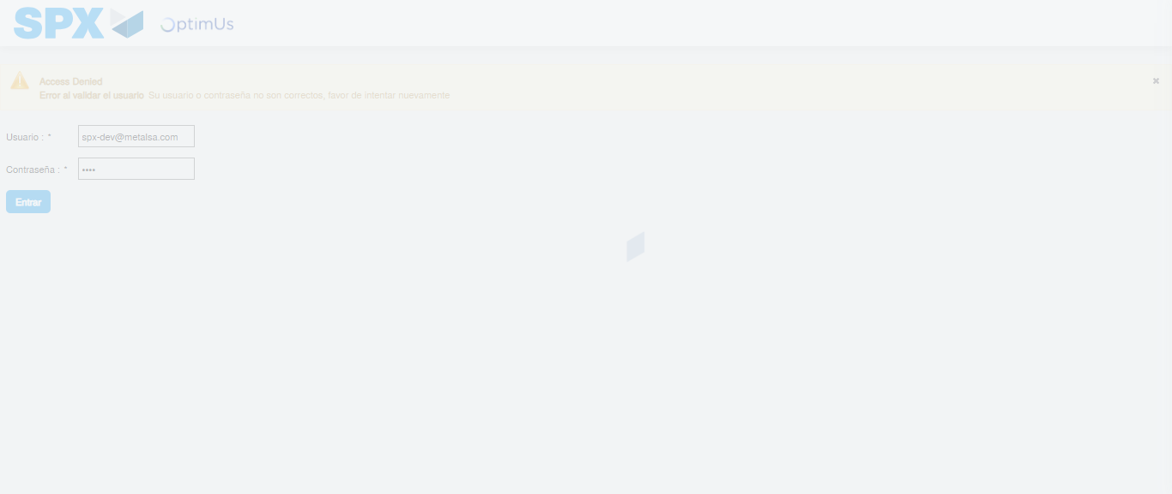Image file-name: QC_Testing-tc001_SPX_Dev5_Crear_Nueva_Linea_Requisicion_Spot_Tipo_Cobro_CC-1790170846947

Step 2 - Select to UEN and Access to Spot Buy Requisitions : UEN Correctly selected and Correct access
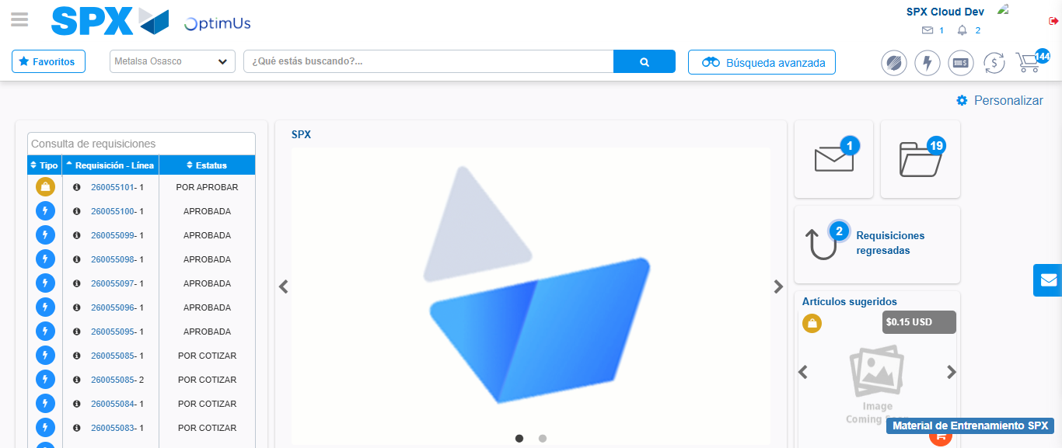Image file-name: QC_Testing-tc001_SPX_Dev5_Crear_Nueva_Linea_Requisicion_Spot_Tipo_Cobro_CC-1790170870749

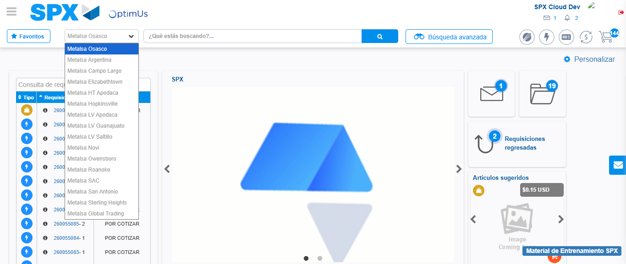Image file-name: QC_Testing-tc001_SPX_Dev5_Crear_Nueva_Linea_Requisicion_Spot_Tipo_Cobro_CC-1790170871773

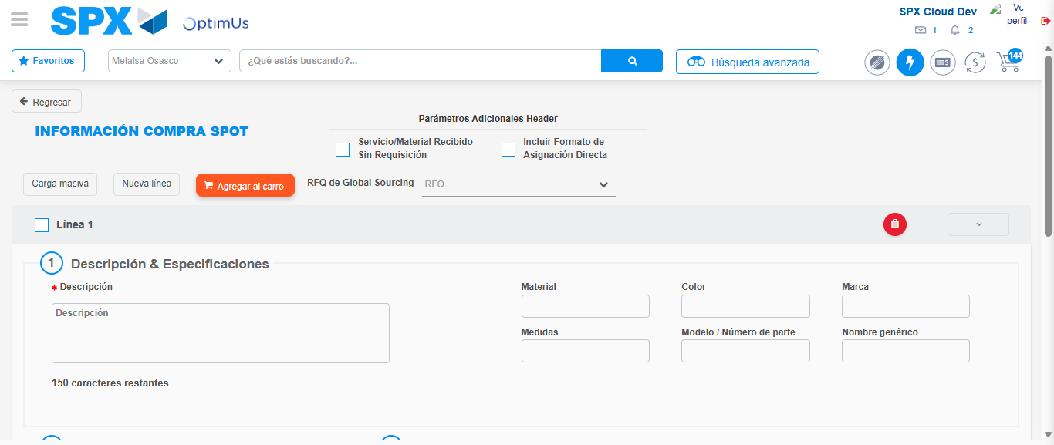Image file-name: QC_Testing-tc001_SPX_Dev5_Crear_Nueva_Linea_Requisicion_Spot_Tipo_Cobro_CC-1790170877412

Step 3 - Data Capture Spot Buy Requisition: Data captured correctly
Image file-name: QC_Testing-tc001_SPX_Dev5_Crear_Nueva_Linea_Requisicion_Spot_Tipo_Cobro_CC-1790170877794

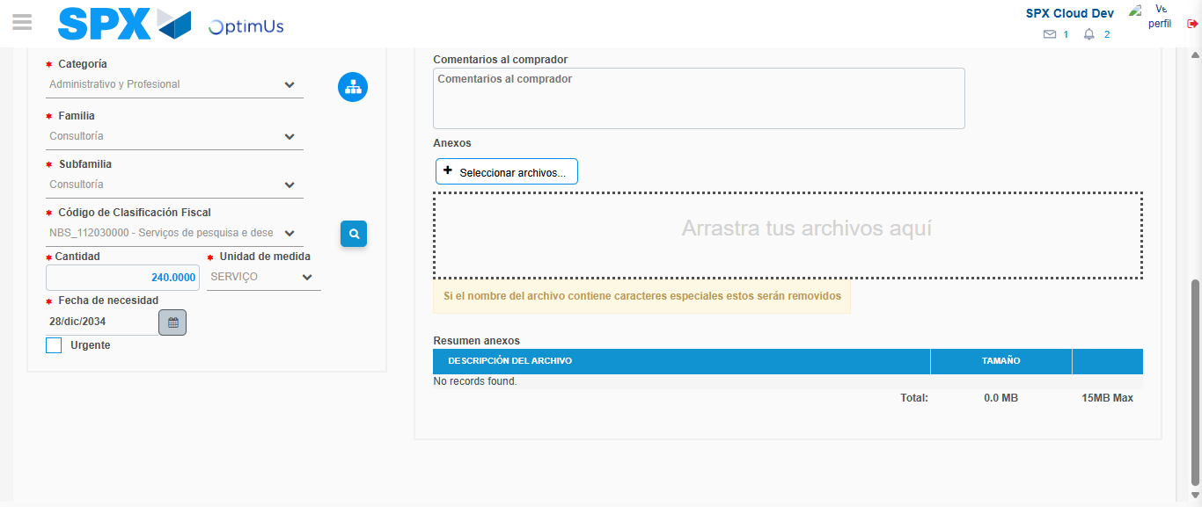Image file-name: QC_Testing-tc001_SPX_Dev5_Crear_Nueva_Linea_Requisicion_Spot_Tipo_Cobro_CC-1790170898056

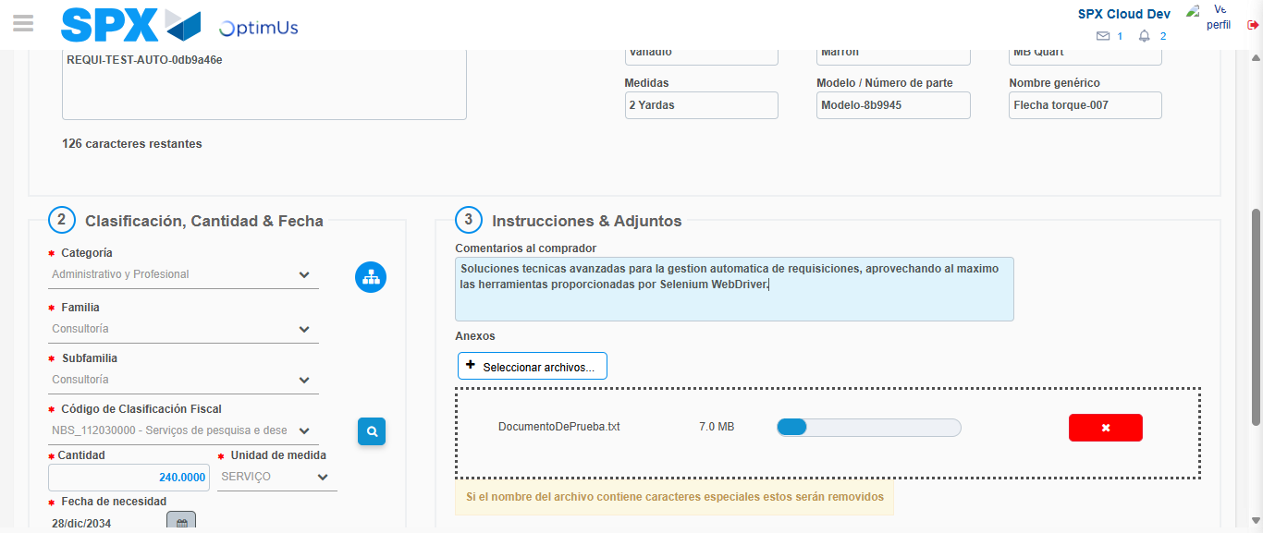Image file-name: QC_Testing-tc001_SPX_Dev5_Crear_Nueva_Linea_Requisicion_Spot_Tipo_Cobro_CC-1790170899286

Step 4 - Add new line and data capture second line: Line add correctly
Image file-name: QC_Testing-tc001_SPX_Dev5_Crear_Nueva_Linea_Requisicion_Spot_Tipo_Cobro_CC-1790170877794

Image file-name: QC_Testing-tc001_SPX_Dev5_Crear_Nueva_Linea_Requisicion_Spot_Tipo_Cobro_CC-1790170898056

Image file-name: QC_Testing-tc001_SPX_Dev5_Crear_Nueva_Linea_Requisicion_Spot_Tipo_Cobro_CC-1790170899286

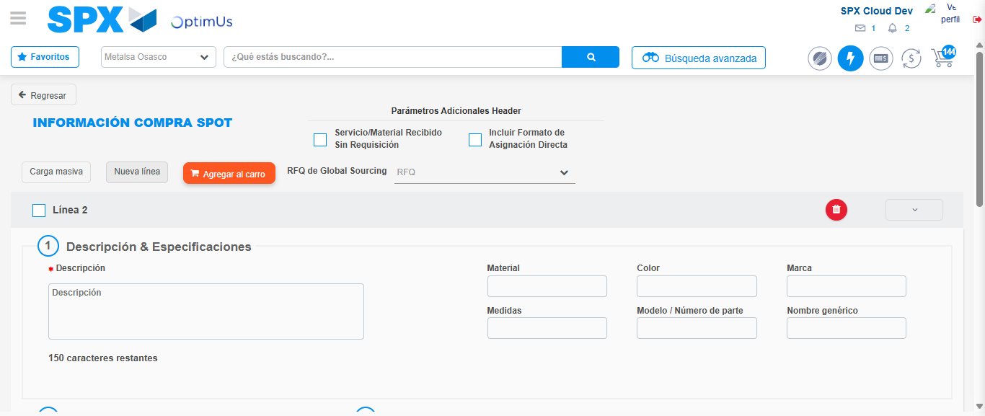Image file-name: QC_Testing-tc001_SPX_Dev5_Crear_Nueva_Linea_Requisicion_Spot_Tipo_Cobro_CC-1790170901781

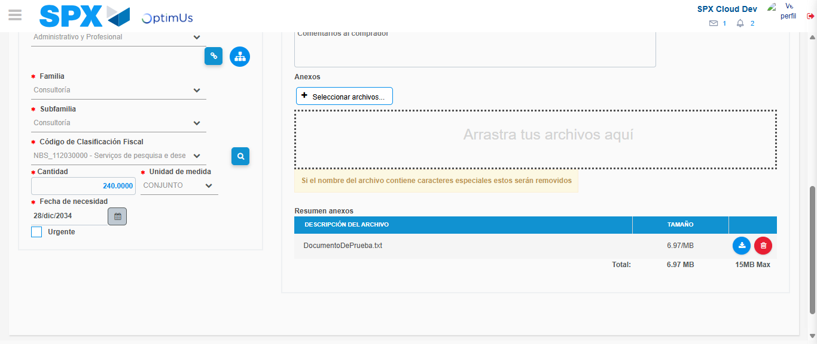Image file-name: QC_Testing-tc001_SPX_Dev5_Crear_Nueva_Linea_Requisicion_Spot_Tipo_Cobro_CC-1790170922318

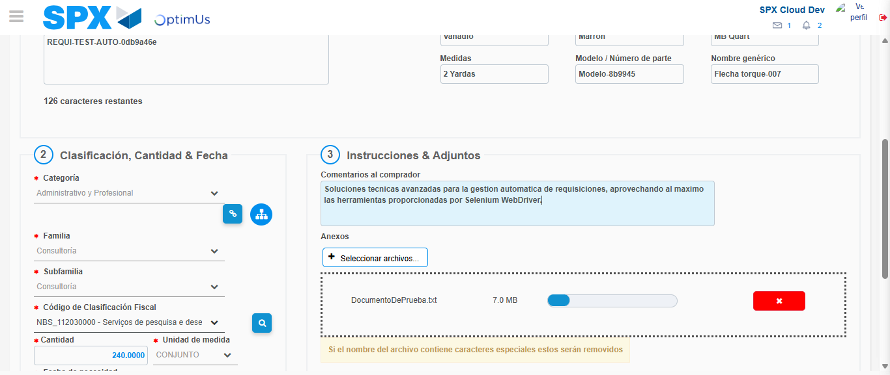Image file-name: QC_Testing-tc001_SPX_Dev5_Crear_Nueva_Linea_Requisicion_Spot_Tipo_Cobro_CC-1790170923563

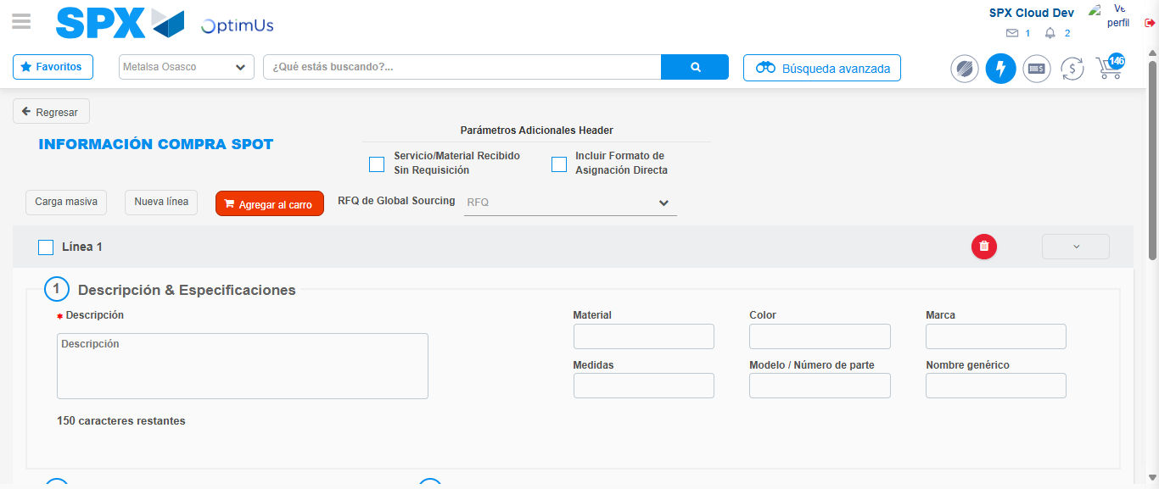Image file-name: QC_Testing-tc001_SPX_Dev5_Crear_Nueva_Linea_Requisicion_Spot_Tipo_Cobro_CC-1790170933844

Step 8 - Return to Main Page SPX : Return to Main Page SPX
Image file-name: QC_Testing-tc001_SPX_Dev5_Crear_Nueva_Linea_Requisicion_Spot_Tipo_Cobro_CC-1790170870749

Image file-name: QC_Testing-tc001_SPX_Dev5_Crear_Nueva_Linea_Requisicion_Spot_Tipo_Cobro_CC-1790170871773

Image file-name: QC_Testing-tc001_SPX_Dev5_Crear_Nueva_Linea_Requisicion_Spot_Tipo_Cobro_CC-1790170877412

Image file-name: QC_Testing-tc001_SPX_Dev5_Crear_Nueva_Linea_Requisicion_Spot_Tipo_Cobro_CC-1790170936232

Image file-name: QC_Testing-tc001_SPX_Dev5_Crear_Nueva_Linea_Requisicion_Spot_Tipo_Cobro_CC-1790170936527

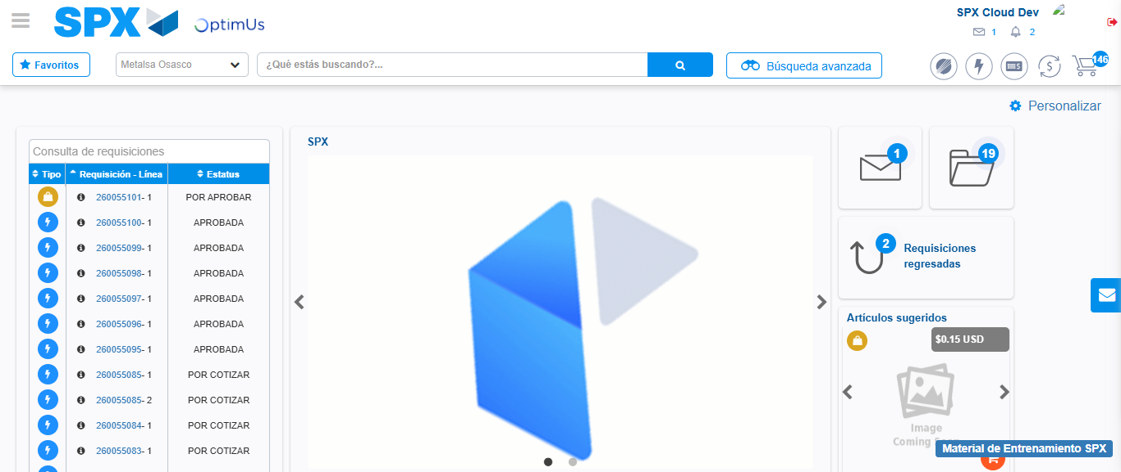Image file-name: QC_Testing-tc001_SPX_Dev5_Crear_Nueva_Linea_Requisicion_Spot_Tipo_Cobro_CC-1790170962524

Step 9 - Log Out : Log Out SPX
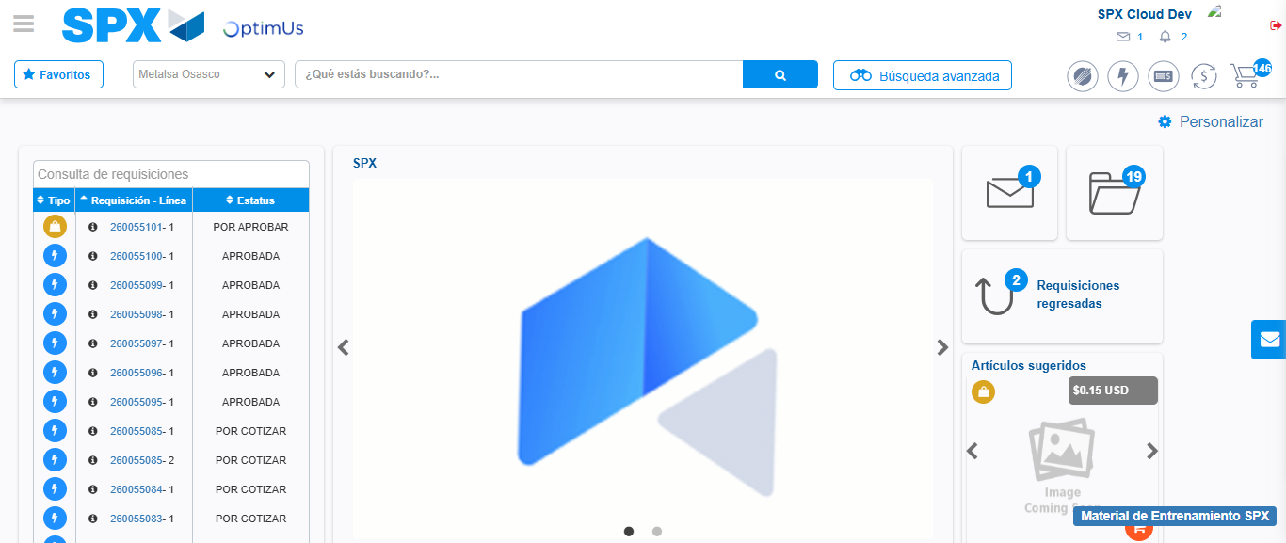Image file-name: QC_Testing-tc001_SPX_Dev5_Crear_Nueva_Linea_Requisicion_Spot_Tipo_Cobro_CC-1790170962920

